The primary objective of this study is to identify and analyze the various factors that may contribute to the onset of myopia in children. Using a subset of data from the Orinda Longitudinal Study of Myopia (OLSM) that includes 618 subjects who were not myopic upon entry and had a minimum of five years of follow-up, we aim to explore the impact of ocular anatomy, family history of myopia, and lifestyle choices related to visual activities. The study will utilize statistical methods to establish correlations between these variables and the development of myopia over a five-year period. By achieving this objective, the study aims to provide deeper insights into myopia risk factors, potentially informing future preventive measures and treatment options.
There are 18 variables in this data, some are categorical, and some continuous. The variables are as such, ID is the subject identifier, almost as if it were the subject’s name, and thus will not be used by us. STUDYYEAR is the year the subject entered the study and ranges from 1990-1995, and while it could be used, it likely isn’t significant and not really intended to be used for the purposes of predicting myopia. Speaking of myopia, MYOPIC is either 0 for no or 1 for yes if the subject developed myopia within the first 5 years of the follow up. Whether a subject is myopic or not is defined as the sphere equivalent refraction being less than or equal to -0.75. AGE is the subject’s age at the first visit measured in years and GENDER is the subject’s gender where 0 is male and 1 is female. SPHEQ, the spherical equivalent refraction, is a measure of the eye’s effective focusing power, measured in Diopters. Eyes that are “normal”, ones that don’t require glasses or contact lenses, have spherical equivalents between -0.25 and 1. The more negative the spherical equivalent, the more myopic the subject. AL is the axial length, measured in millimeters, which is the length of the eye from the front to the back. ACD is the anterior chamber length, measured in millimeters, which is the length from the front to the back of the aqueous-containing space of the eye between the cornea and the iris. LT is the lens thickness, measured in millimeters, which is the length from the front to the back of the crystalline lens. VCD is the vitreous chamber depth, measured in millimeters, which is the length from the front to the back of the aqueous-containing space of the eye in front of the retina. SPORTHR is the amount of hours per week outside of school the child spent engaging in sports or outdoor activities. READHR is the amount of hours per week outside of school the child spent reading for pleasure. COMPHR is the amount of hours per week outside of school the child spent using a computer. STUDYHR is the amount of hours per week outside of school the child spent reading or studying for school assignments. TVHR is the amount of hours per week outside of school the child spent watching TV. DIOPTERHR is a composite of near-work activities, measured in hours per week, which is calculated by this formula. DIOPTERHR = 3*(READHR + STUDYHR) + 2*COMPHR + TVHR. This suggests that whoever made this variable, they think, contrary to what we’ve heard all of our lives, that reading and studying hurts your eyes more than using a computer, and significantly more than watching TV, judging by how they weighed this formula. Since DIOPTERHR is a combination of other variables, we will not be able to use it with the other variables for regression. MOMMY and DADMY ask the question of if the subject’s parents were myopic, with a 0 meaning that parent wasn’t myopic, and 1 meaning the parent was myopic.
These variables might be indicators of myopia, which is why this study looks at them specifically. Age seems the least important in this, since all of the subjects are young, and around the age where they would develop myopia, but you never truly know. Gender also seems not important, but as many different diseases and other afflictions affect men and women differently and at different rates, this may be worth looking into. The sphere refraction equivalent is important as it is the defining factor of whether someone is deemed myopic. The size variables (AL, ACD, LT, VCD) could also be important due to some saying that having “too big” eyes is an indicator of myopia. The variables considering time spent in certain activities also have claims to be important as more time staring at words and other things and especially screens are known to affect our eyes in various ways, possibly causing myopia. And of course family history of myopia as myopia is believed to be genetic in some ways, so asking whether the parents of the subject have myopia may be important.
Running the model with all applicable variables gives us this model.
Log(Odds(MYOPIC)) = -4.4415 + .0388 * AGE - .6172 * GENDER + 4.1051 * SPHEQ + 30.4773 * AL - 31.6218 * ACD - 29.6168 * LT - 30.1044 * VCD + .0511 * SPORTHR - .0795 * READHR -.0425 * COMPHR + .1734 * STUDYHR + .0155 * TVHR - .7146 * MOMMY - .7771 * DADMY
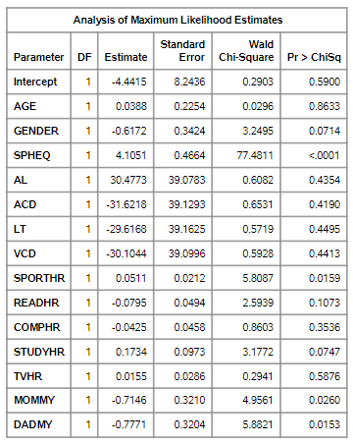
All of the Chi-Square p-values for the variables are listed in the table above. This tells us that the only variables that are significant at the α = .05 level. Those being SPHEQ, SPORTHR, MOMMY, and DADMY. These will be the 4 variables that we will use in the final model, but we will reduce and try a few others before then.
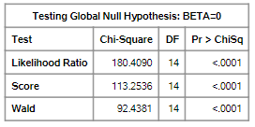
The Wald test for the whole model gives a really small p-value, so the model itself is significant despite most of the variables not being significant.
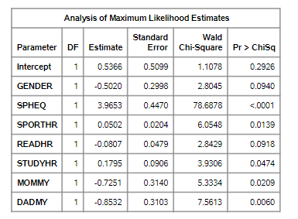
Removing the variables in the full model that have a p-value > .2 leaves us with 7 variables in the model. I think this is a pretty good set of variables here, and in some cases I may decide to stop here, but we will keep going until all variables have a p-value < .05.
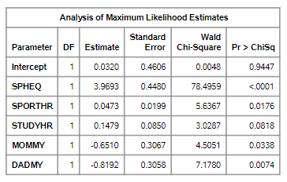
Removing the 2 variables in the previous model with p-values around .09 gives us this model, which despite STUDYHR being < .05 in the previous model, it is now > .05, requiring us to do one more run of the model, removing this last variable.
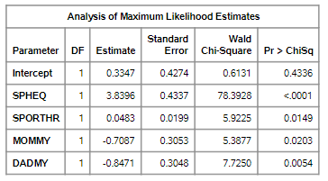
This is the final model we will be using.
Probability(MYOPIC) = e.3347 + 3.8396 * SPHEQ + .0483 * SPORTHR - .7087 * MOMMY - .8471 * DADMY / 1 + e.3347 + 3.8396 * SPHEQ + .0483 * SPORTHR - .7087 * MOMMY - .8471 * DADMY
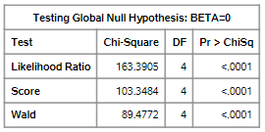
This model, much like the full model, also has a really small p-value, meaning that it is significant.
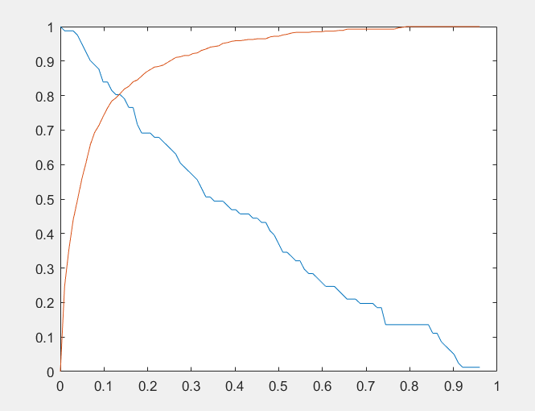
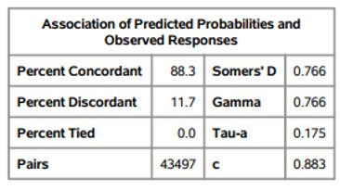
Graphing the specificity of the model and the sensitivity of the model vs percentage gives us an optimum predicting probability where the 2 lines meet at around 13%. The correct prediction percentage at this point is 88.3%, which is pretty good.
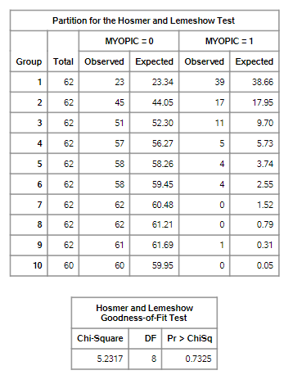
Above is the result of the Hosmer Lemeshow Goodness-of-Fit Test. With a p-value of .7325 for this test, this would suggest that the model is a good fit.
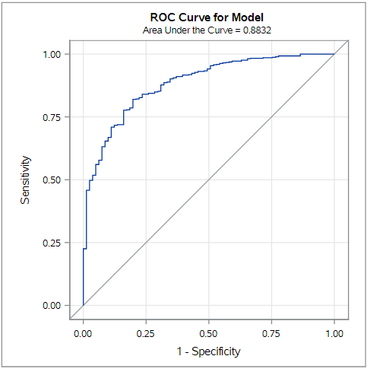
Above is the ROC Curve for the model. The curve, along with the stated area under the curve of .8832, tells us that the model is pretty accurate at predicting the outcome.
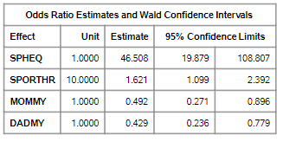
Finally, we have the Odds Ratios for the variables. For SPHEQ, we are compaing the mean value of around .8 to 1.8, which tells us that people are significantly more likely to be myopic if their sphere refraction equivalent is lower. For SPORTHR, we are comparing the mean value of around 12 to around 22, which tells us that people are a good bit more likely to be myopic with less hours spent playing sports or doing other outdoor activities. For both MOMMY and DADMY, we are comparing 0 to 1, which tells us that subjects are around half as likely to be myopic if their parents aren’t myopic than if they are. The 95% confidence intervals for those values are also listed in the above table.
In conclusion, our final model is pretty good at predicting whether or not someone is myopic. And we can see that the effects that these variables have on the predicted outcome are pretty much as we expected, higher SPHEQ and SPORTHR values decrease the likelihood of someone being myopic, and a family history of myopia increases the likelihood of someone being myopic.
As for our group, everyone seemed to pull their weight, nobody did less than anyone else, and everybody showed up to all of the meetings. I don’t think there’s really much to say on this matter.

The SAS code:
/*Importing the data*/
proc import datafile="M:\My_Private_Files\STAT458\MYOPIA.txt" dbms=tab out=data replace;
run;

proc means data=data;
run;

proc freq data=data;
tables myopic gender age mommy dadmy;
run;

/*Creating the Scatterplots*/
proc sgplot data=data;
scatter x=age y=myopic;
run;

proc sgplot data=data;
scatter x=gender y=myopic;
run;

proc sgplot data=data;
scatter x=SPHEQ y=myopic;
run;

proc sgplot data=data;
scatter x=AL y=myopic;
run;

proc sgplot data=data;
scatter x=ACD y=myopic;
run;

proc sgplot data=data;
scatter x=LT y=myopic;
run;

proc sgplot data=data;
scatter x=VCD y=myopic;
run;

proc sgplot data=data;
scatter x=SPORTHR y=myopic;
run;

proc sgplot data=data;
scatter x=READHR y=myopic;
run;

proc sgplot data=data;
scatter x=COMPHR y=myopic;
run;

proc sgplot data=data;
scatter x=STUDYHR y=myopic;
run;

proc sgplot data=data;
scatter x=TVHR y=myopic;
run;

proc sgplot data=data;
scatter x=DIOPTERHR y=myopic;
run;

proc sgplot data=data;
scatter x=MOMMY y=myopic;
run;

proc sgplot data=data;
scatter x=DADMY y=myopic;
run;

/*Running the full model*/
proc logistic data=data plots=all;
model myopic=age gender spheq al acd lt vcd sporthr readhr comphr studyhr tvhr mommy dadmy;
run;

/*Reduced model with alpha as .2*/
proc logistic data=data plots=all;
model myopic=gender spheq sporthr readhr studyhr mommy dadmy;
run;

/*Reduced again*/
proc logistic data=data plots=all;
model myopic=spheq sporthr studyhr mommy dadmy;
run;

/*reduced again*/
proc logistic data=data plots=all;
model myopic=spheq sporthr mommy dadmy;
run;

/*Final reduced model*/
proc logistic data=data plots=all;
model myopic=spheq sporthr mommy dadmy / lackfit clodds=both;
units sporthr=10 spheq=1 mommy=1 dadmy=1;
run;

For the sake of space I will only put the section of code used to get the predicted probability graph, and not the whole MatLab code used to make the model.
nc=99;
C11=zeros(nc,1);
C10=C11;
C01=C11;
C00=C11;
K=C11;
K(1)=0.5;
for i=1:nc
K(i)=PL+(i-1)*PR/nc;
end
for j=1:nc
for i=1:n
if Y(i)==1 & LXB(i) >= K(j)
C11(j)=C11(j)+1;
end
if Y(i)==1 & LXB(i) < K(j)
C10(j)=C10(j)+1;
end
if Y(i)==0 & LXB(i) >= K(j)
C01(j)=C01(j)+1;
end
if Y(i)==0 & LXB(i) < K(j)
C00(j)=C00(j)+1;
end
end
end
for j=1:nc
K(j);
[C11(j) C10(j);
C01(j) C00(j)];
C11(j)+C00(j);
%Sensitivity
y(j)=C11(j)/(C11(j)+C10(j));
%1-Specificity
x(j)=1-C00(j)/(C00(j)+C01(j));
%Specificity
x2(j)=C00(j)/(C00(j)+C01(j));
end
plot(K,y,K,x2)

Note: We probably could have gotten the information needed for the predicted probability in SAS, but since we don’t know how right now, using MatLab is a good solution.

